**WORD COUNT**

This program counts the number of lines, words, and characters in a given file. Declare two functions named wordcount and linecount in your program. The linecount function was overloaded according to the transfer argument. Entering content about a file invokes the linecount function (if the specified file exists). Otherwise, the main function itself counts characters and lines, except when the wordcount function counts words (in this state, the number of lines is always just 1).



This program uses Swing in Java to create a simple word counting app. This app counts words in a text area and also changes the color of the text. Although this program is specially made for word counting. It uses Swing, applets and frameworks.

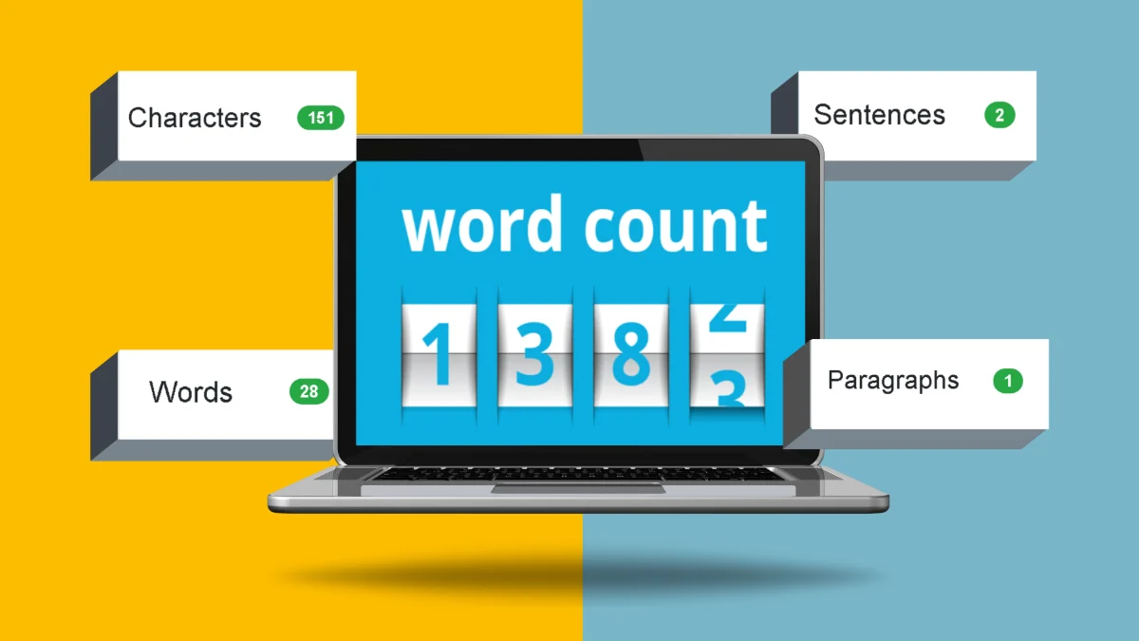

Without wasting any more time, here are my three solutions to this common coding problem. The first uses the split() method of the String class, the second uses the String Tokenizer, and the third solves this problem without using APIs or library methods.



**ALGORITHM**

The algorithm becomes very simple.

* String contains words if you initialize the count to 1 as if the string contains no spaces.
* Check if there is space.
* If you find a space, check the next character. If it's not a space, then the word was found within the string. Increment the count variable.
* When the end of the string is reached, the count variable contains the number of words in the string.



OUTPUT SCREEN: 1

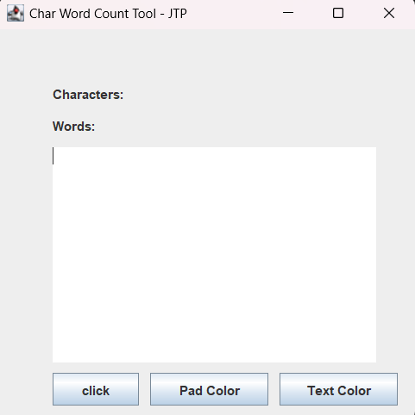

OUTPUT SCREEN: 2

